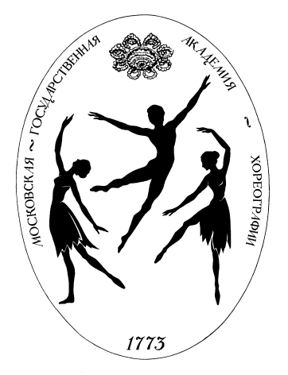 Министерство культуры Российской Федерации

федеральное государственное образовательное учреждение
высшего профессионального образования
«Московская государственная академия хореографии»

Mailing address: 2nd Frunzenskaya ul., 5, Moscow, Russia, 119146
Tel/Fax: (7-095) – 499 -242 – 86 – 36 – The Department for International Programs
E – mail: mgah-bia@yandex.ru

APPLICATION FORM
Please, type or print clearly:

Last name_______________________________________________________________________________________

First name___________________________________Middle name_________________________________________

Date of birth: “____”_____________20____ Sex: male ________ female ________

Mailing address: zip code _______________ country ____________________________________________________

city ___________________________________ street ____________________________________________________

building ______________________________ apartment___________________________________________________

Phone: _____________________________Fax: ______________________ e-mail: _____________________________

Permanent address: zip code __________________ country _______________________________________________

city ___________________________________ street ____________________________________________________

building ______________________________ apartment___________________________________________________

Phone: _____________________________Fax: ______________________ e-mail: _____________________________

Parents/ legal guardians of the STUDENT:

Names: ___________________________________________________________________________________________

Adress: ___________________________________________________________________________________________

Phone: _____________________________Fax: ______________________ e-mail: _____________________________

Summary of academic background

Dates of attendance | Education (secondary and ballet)  (name of school/college) | Degree (Certificate) obtained

Russian Language level:

Elementary _______, Basic (Waystage user) _________, First (Threshold) __________

Information for visa support:

Citizenship______________________________________________ (if more than one, please indicate them using comas)

Permanently I live in _____________________________(country) _____________________________________(region)

Place of birth ______________________________ (country) ____________________________________ (city)

Russian Embassy/Consulate where you wish to obtain visa: ______________________________________(country)
__________________________ (city)

Name of school/college:
_________________________________________________________________________________________________

Address: __________________________________________________________________________________________

Phone: ___________________________________ Fax: ____________________________________________________

Parents/guardians of a student:
Names ___________________________________________________________________________________________

Contacts _________________________________________________________________________________________

Position of a student in the Bolshoi Ballet Academy (traineeship program or full-time educational program): _________________________________________________________________________________________________

Proposed date of arrival to Moscow: ________ (day) _________________ (month) _________ (year)

Please, send this application by e-mail: mgah-bia@yandex.ru

I declare that all above information is correct. I have been informed on the regulations of admittance to the Academy and on the tuition fee. I am prepared to timely cover the expenses of studing and living in Russian Federation. If I am enrolled to the Bolshoi Ballet Academy I will observe contract conditions and immigration regulations in Russia.

Date: _____ (day) _________________ (month) ________ (year) Signature ________________________________

